**Faculty Member: Date:** .

**Semester: Section:** .

**EE-351 Communication Systems**

**Lab 8:**  **SSB RECEPTION**

|  |  |  |  |  |  |  |
| --- | --- | --- | --- | --- | --- | --- |
|  |  | **PLO4-CLO3** | | **PLO5-CLO4** | **PLO8-CLO5** | **PLO9-CLO6** |
| **Name** | **Reg. No** | **Viva / Quiz / Lab Performance** | **Analysis of data in Lab Report** | **Modern Tool Usage** | **Ethics and Safety** | **Individual and Team Work** |
|  |  | **5 Marks** | **5 Marks** | **5 Marks** | **5 Marks** | **5 Marks** |
|  |  |  |  |  |  |  |
|  |  |  |  |  |  |  |
|  |  |  |  |  |  |  |

**Lab 8: SSB Reception**

**Objectives**

At the competition of this lab, you will be able to describe SSB reception circuits and signals by using AM/SSB RECIEVER circuit BLOCK on the ANALOG COMMUNICATION CIRCUIT BOARD.

**Lab Instructions**

* The students should perform and demonstrate each lab task separately for stepwise evaluation
* Each group shall submit lab report on LMS within 6 days after lab is conducted. Lab report submitted via email will not be graded.
* Students are however encouraged to practice on their own in spare time for enhancing their skills.
* Complete as many problems as you can within the allotted time.
* Talk to your classmates for help

**Lab Report Instructions**

All questions should be answered precisely to get maximum credit. Lab report must ensure following items:

* Lab objective
* Results (screen shots) duly commented and discussed.
* Conclusion

**Exercise 1 (RF Stage, Mixer, and IF Filter)**

**Introduction:**

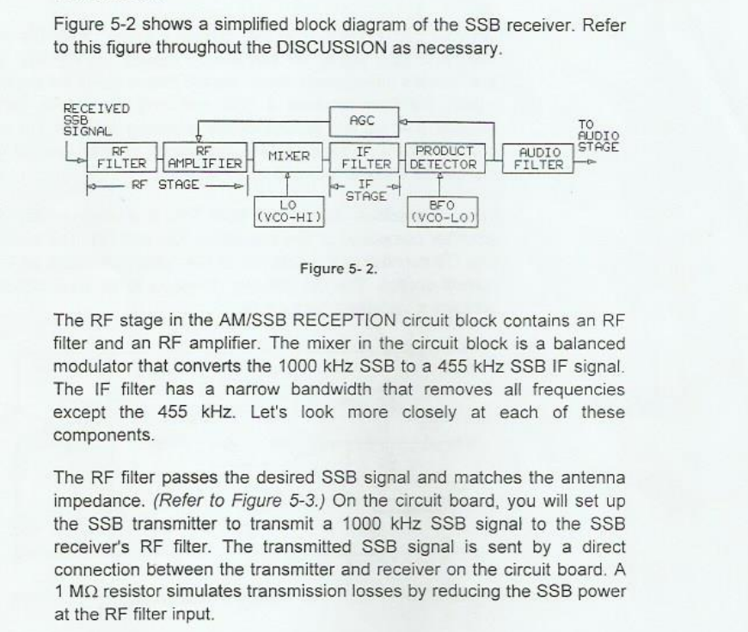

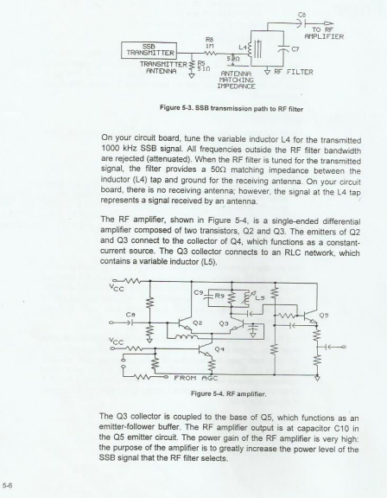

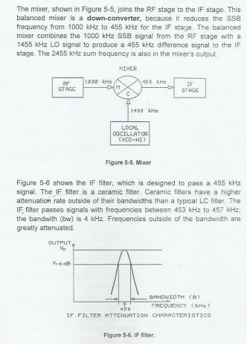

**Tasks (Exercise 1)**

**Procedure A: Connect the SSB Transmitter**

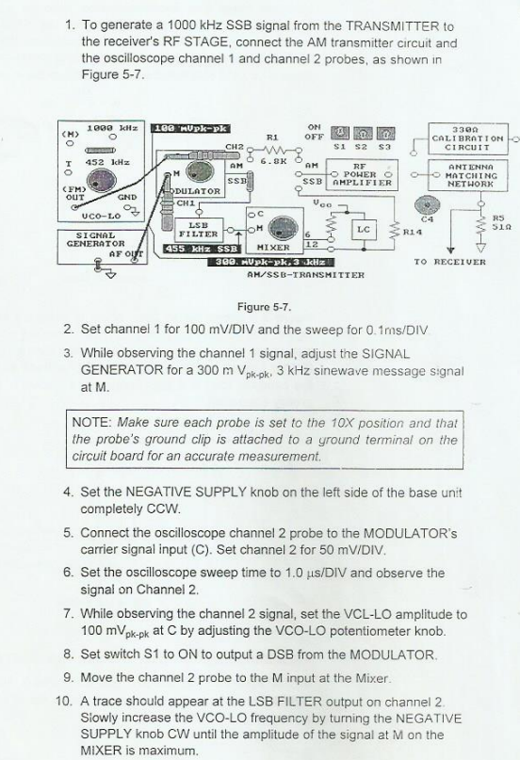

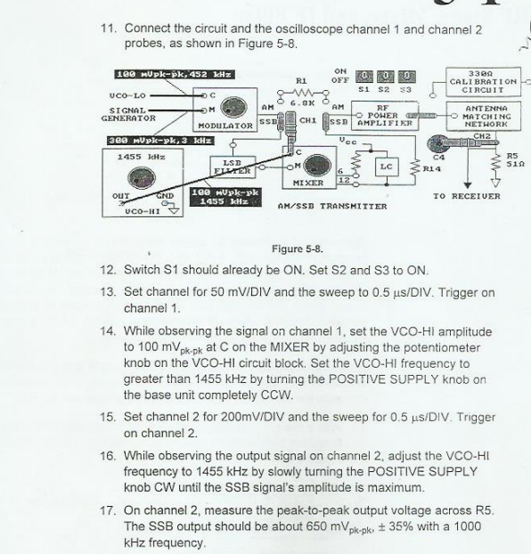

**Procedure B: RF Filter (Tune in the SSB Signal)**

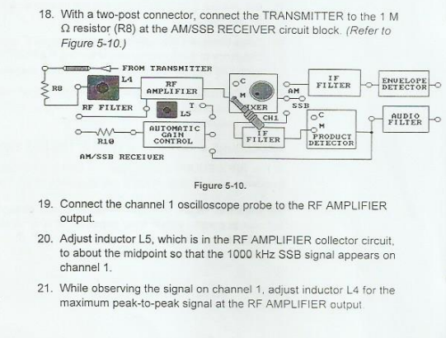

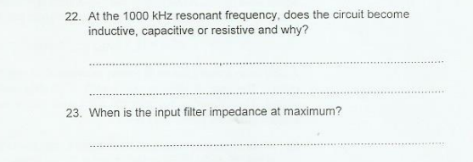

**Procedure C: The RF Amplifier (Calculate Power Gain)**

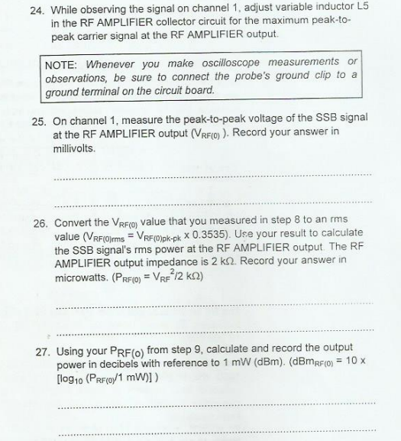

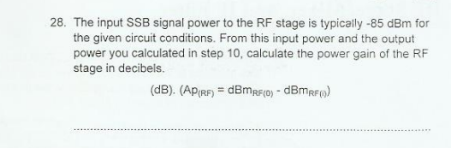

**Procedure D: Mixer and IF Filter (produce a 455KHz SSB)**

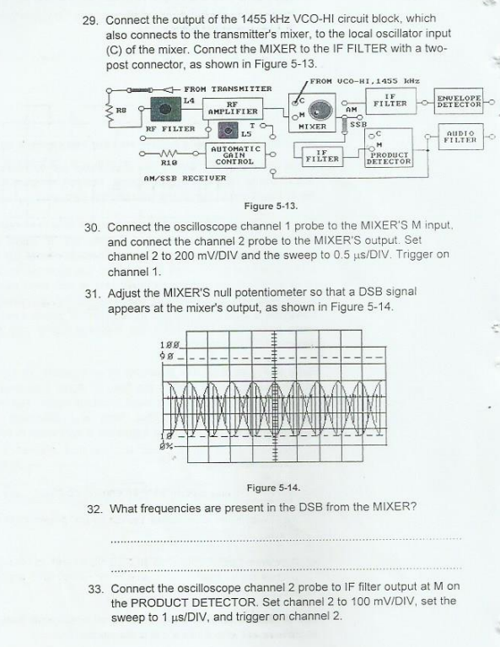

**Exercise (2): Product Detector**

**Procedure A:Connect and Adjust SSB transmitter and Reciever if not done yet**

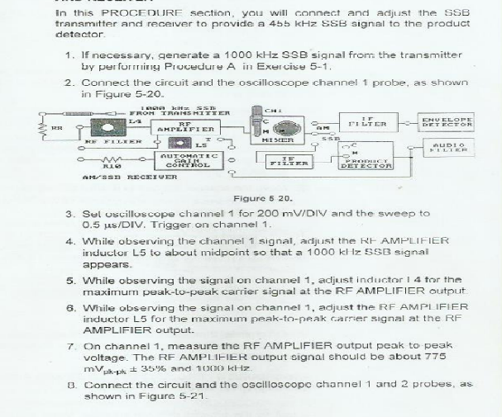

**Procedure B: Product Detector And Audio Filter(Recover the message Signal)**

